# About

This walkthrough will guide you in order to use the UMA’s ping Android application.

# Ping Application

This application acts as a wrapper for the Ping application on Android devices and is intended for use as a traffic generator during network performance test. The application can be used directly from the user interface or remotely, making it ideal for automatic testing.

# Usage

The application can be used on the terminal with the provided user interface, or remotely through adb commands.

## Adb commands

The application can be used remotely sending intents to the service via the startservice command of adb:

adb shell am startservice -n com.uma.ping/.PingService

The application accepts the following intents (-a):

com.uma.ping.START ***(Requires parameters)***

com.uma.ping.STOP

Parameters for configuring Ping are passed as a comma separated list of (key)=(value) pairs with no spaces, using the intent extra (-e) com.uma.ping.PARAMETERS.

All of the following parameters need to be specified:

* + - **target:** HostName or IP of the target machine.
    - **ttl:** IP time to live.

In some cases, it is necessary to specify the user of the command with --user 0, this flag does not seem to have any adverse effect, so it is recommended to use it always.

**EXAMPLES**

adb shell am startservice -n com.uma.ping/.PingService -a com.uma.ping.START -e com.uma.ping.PARAMETERS \"target=127.0.0.1,ttl=128\" --user 0

adb shell am startservice -n com.uma.ping/.PingService -a com.uma.ping.STOP

## Device Interface

The application can be used through the device interface. The ping parameters are configured through the text fields (1) and executed/stopped pressing the button Start/Stop *(2)*.

Once the ping agent is initiated, the Log *(3)* will be updated during the execution.

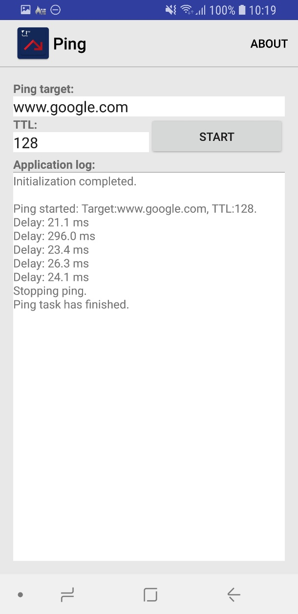

**3**

**1**

**1**

**2**

Figure 1: Application Interface